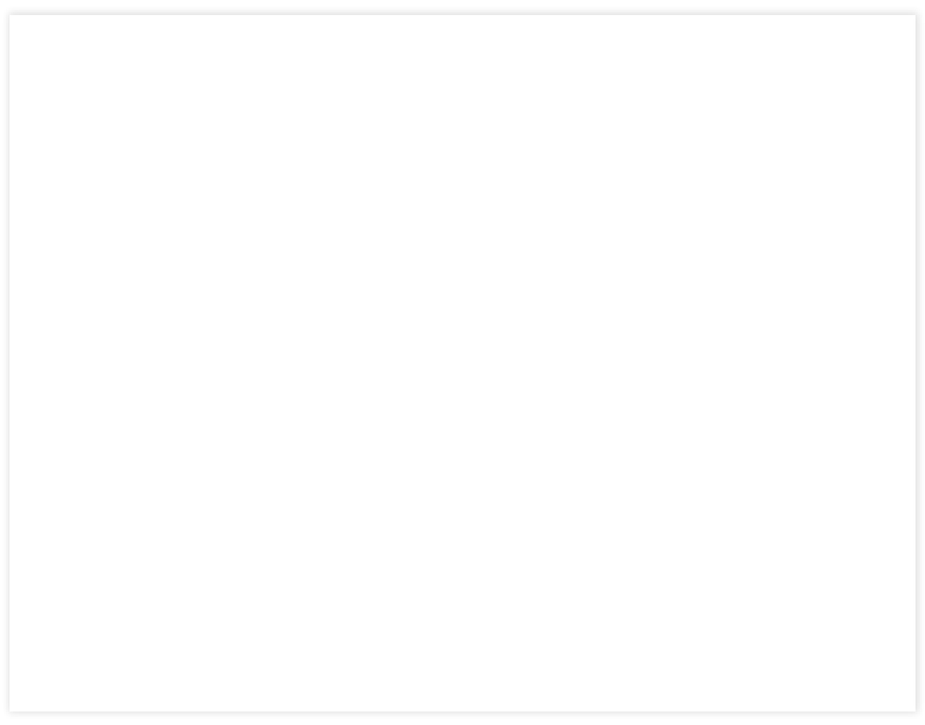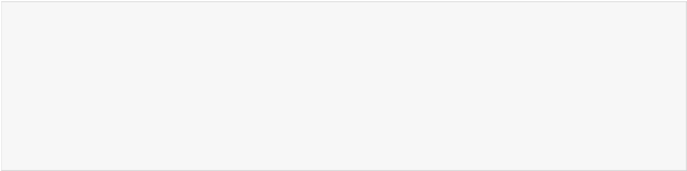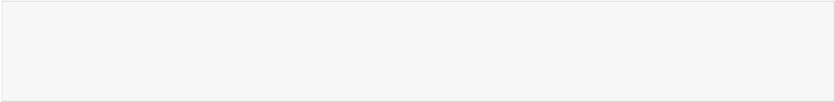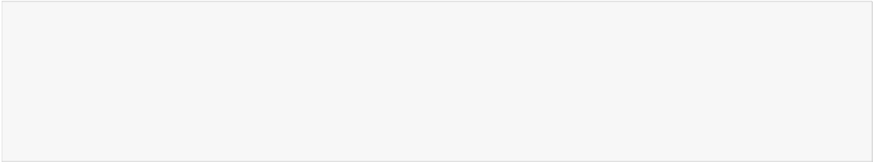

In [1]:

import numpy as np#used for numerical analysis

import tensorflow #open source used for both ML and DL for computation

from tensorflow.keras.models import Sequential #it is a plain stack of layers

from tensorflow.keras import layers #A layer consists of a tensor-in tensor-out computati on function

# #Dense layer is the regular deeply connected neural network layer

from tensorflow.keras.layers import Dense,Flatten

# #Faltten-used fot flattening the input or change the dimension

from tensorflow.keras.layers import Conv2D,MaxPooling2D,Dropout #Convolutional layer #MaxPooling2D-for downsampling the image

from keras.preprocessing.image import ImageDataGenerator

In [2]:

# #setting parameter for Image Data agumentation to the training data

train_datagen = ImageDataGenerator(rescale=1./255,shear_range=0.2,zoom_range=0.2,horizont al_flip=True)

# #Image Data agumentation to the testing data

test_datagen=ImageDataGenerator(rescale=1./255)

In [3]:

# #performing data agumentation to train data

x_train = train_datagen.flow_from_directory( r'C:\Users\Training\Dataset\TRAIN_SET',

target_size=(64, 64),batch_size=5,color_mode='rgb',class_mode='sparse')

#performing data agumentation to test data x_test = test_datagen.flow_from_directory( r'C:\Users\Training\Dataset\TEST_SET',

target_size=(64, 64),batch_size=5,color_mode='rgb',class_mode='sparse')

Found 4138 images belonging to 5 classes. Found 929 images belonging to 3 classes.